## **NATIONAL UNIVERSITY OF MODERN LANGUAGES, ISLAMABAD**

## NUML logo, Vector Logo of NUML brand free download (eps, ai, png, cdr ...

**Web Engineering - Lab**

**Lab # 2**

**Submitted By**

**Umer Hassan Khan**

**SP21020**

**Submitted To**

**Ma’am Nabeela Bibi**

**Date: 02/10/2023**

## **Task 1**

**Create a Wiki page related to a topic of your choice. Create at least two HTML pages for references and link the main Wiki page to those references. Use necessary File paths to images and Add formatted textual information on your Wiki. Include a table like the following in your Wiki page**

<!DOCTYPE>

<html>

<head>

<title>Babar Azam</title>

</head>

<body>

<h1>Babar Azam</h1>

<p1><b>Mohammad Babar Azam</b>, is a <strong>Pakistani international cricketer</strong> and current <i>captain</i> of the Pakistan national cricket team in all formats.<sup>1</sup>

<br> He is widely regarded as one of the finest batters in contemporary cricket.<sub>2</sub>

<br>

He is <a href="https://www.icc-cricket.com/rankings/mens/player-rankings/2759">ranked</a> as the number one batter in ODIs and third in T20Is and fourth in Tests.

<br>A right-handed top-order batter, he captains Peshawar Zalmi in the <abbr title="Pakistan Super League">PSL</abbr> and Central Punjab in Pakistan's domestic cricket.

<br>With 42 wins, he is the joint most successful T20I captain of all time.</p1>

<a href="https://www.espncricinfo.com/cricketers/babar-azam-348144">Career</a>

<br>

<br>

<img src="https://th.bing.com/th/id/OIP.EKB_PxsIUY1NJMbJYs-iTAHaKj?w=121&h=180&c=7&r=0&o=5&pid=1.7" width="10%" height="30%" alt="....">

<br>

<a href="file:///C:/Users/user/Documents/index1.html">ICC Cricket World Cup 2023</a>

</body>

</html>

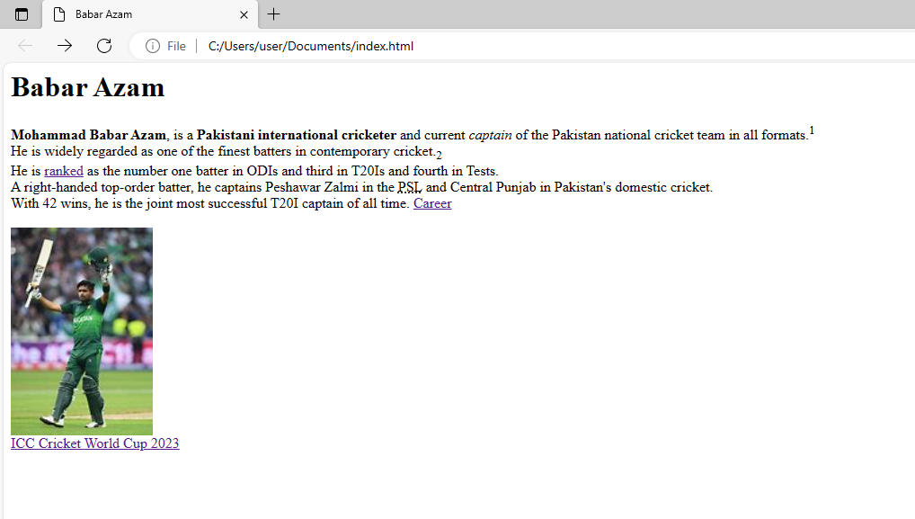

## **Task 2**

**Create a Simple web page about any latest topic of your choice e.g “ emerging software technologies now days”. Following things should be considered 1. Use all the appropriate Html Commands 2. Write Description of topic 3. Use animated images as well as use those images as a link 4. Make usage of mailto**

<!DOCTYPE>

<html>

<head>

<title>ICC Cricket WorldCup 2023</title>

</head>

<body>

<h1>ICC Cricket WorldCup 2023</h1>

<a href="https://media1.giphy.com/media/unF4VkdR6ZcPeh7F8R/200w.webp?cid=ecf05e470o59rtlv3nkh342b1kl1vd76s4ru6h1chb5ps6cx&ep=v1_gifs_search&rid=200w.webp&ct=g"><img src="https://media1.giphy.com/media/unF4VkdR6ZcPeh7F8R/200w.webp?cid=ecf05e470o59rtlv3nkh342b1kl1vd76s4ru6h1chb5ps6cx&ep=v1_gifs_search&rid=200w.webp&ct=g" alt="...."></a>

<br><br><br>

<p1><b>The International Cricket Council (ICC)</b> today announced the schedule for the ICC Men’s Cricket World Cup 2023 at a

‘Countdown to the <i>ICC Men’s Cricket World Cup 2023’</i> event in Mumbai.<br>

Ahmedabad to host World Cup opener between England and New Zealand on 5 October as well as the final on 19 November

<br>

Nine more venues confirmed for the ‘biggest Cricket World Cup ever’

Graphics available in the Online Media Zone for free editorial use

Ten teams feature in what will be the biggest Cricket World Cup ever, to be played across 10 venues from 5 October to 19 November,

with the Narendra Modi Stadium in Ahmedabad hosting the tournament opener and the final.

<br>

The other nine venues are Bengaluru, Chennai, Delhi, Dharamsala, Hyderabad, Kolkata, Lucknow, Mumbai and Pune.

Guwahati and Thiruvananthapuram will join Hyderabad in hosting the practice games.

<br><br>

Defending champions England will take on New Zealand in a much-awaited clash between the 2019 World Cup finalists that opens the tournament in Ahmedabad,

while hosts India will face-off against five-time winners Australia in Chennai on 8 October.

<br>

Ahmedabad will also host matches between traditional rivals India and Pakistan (15 October) and Australia and England (4 November).

<br>

Eight teams have qualified for the 46-day event through the Cricket World Cup Super League

while the final two spots will be taken by the finalists of the ICC Cricket World Cup Qualifier taking place in Zimbabwe.

<br><br>

The tournament retains the round-robin format of last time with all teams playing against each other for a total of 45 league matches.

There are six day matches which will start at 10h30 Indian Standard Time <sup>(IST)</sup> while all other matches, including the knockouts, will be <ins>day-night fixtures</ins> starting at 14h00 <sub>IST</sub>.<br><br>

<br>

The top four teams will qualify for the semifinals, to be played in Mumbai on 15 November and in Kolkata on 16 November.

The semi-finals and the final will have reserve days.

<br>

<b>ICC Chief Executive, Geoff Allardice</b> said: “We are delighted to release the <abbr title= "International Cricket Council"> ICC </abbr>Men’s Cricket World Cup 2023 schedule which is always a huge occasion ahead of any global event.

<br>

“Hundreds of millions of fans around the world will be part of what we hope will be the greatest ever Men’s Cricket World Cup

and we know in India the teams will enjoy a unique electric atmosphere concluding with the winners lifting the trophy in the biggest cricket stadium in the world in Ahmedabad.”

<br><br>

<a href="mailto:jayshahsect@icc.com"><mark>BCCI Secretary</mark></a> <b>Jay Shah</b> said: “It’s a matter of great honour and pride to be hosting the ICC Men’s Cricket World Cup

in different cities across India, showcasing the rich diversity of our country.

“The fervour and passion for cricket in India is unique. I am sure fans both here and abroad would be looking forward to the tournament’s return to India

for the first time since 2011, when our team became the first to lift the trophy on home soil.

“I wish all the teams the very best in their preparations and look forward to hosting what promises to be another exciting tournament.”

<br><br>

<br>

<b>ICC Cricket World Cup 2023 Schedule by Venues:</b>

<br>

<br>

<b>Ahmedabad</b>

<br>

5 October – England vs New Zealand<br>

<del>15 October</del>14<sup>th</sup> October – India vs Pakistan<br>

4 November – England vs Australia<br>

10 November – South Africa vs Afghanistan<br>

19 November – Final<br>

<br>

<b>Hyderabad</b>

<br>

6 October – Pakistan vs Qualifier 1<br>

9 October – New Zealand vs Qualifier 1<br>

12 October – Pakistan vs Qualifier 2<br>

<br>

<b>Dharamsala></b>

<br>

7 October – Bangladesh vs Afghanistan (Day Game)<br>

10 October – England vs Bangladesh<br>

16 October – South Africa vs Qualifier 1<br>

22 October – India vs New Zealand<br>

29 October – Australia vs New Zealand (Day Game)<br>

<br>

<b>Delhi</b><br>

7 October – South Africa vs Qualifier 2<br>

11 October – India vs Afghanistan<br>

14 October – England vs Afghanistan <br>

25 October – Australia vs Qualifier 1<br>

6 November – Bangladesh vs Qualifier 2<br>

<br>

<b>Chennai</b>

<br>

8 October – India vs Australia<br>

14 October – New Zealand vs Bangladesh (Day Game)<br>

18 October – New Zealand vs Afghanistan<br>

23 October – Pakistan vs Afghanistan<br>

27 October – Pakistan vs South Africa<br>

<br>

<b>Lucknow</b><br>

13 October – Australia vs South Africa<br>

17 October – Australia vs Qualifier 2<br>

21 October – Qualifier 1 vs Qualifier 2 (Day Game)<br>

29 October – India vs England<br>

3 November – Qualifier 1 vs Afghanistan<br>

<br>

<b>Pune</b>

<br>

19 October – India vs Bangladesh<br>

30 October – Afghanistan vs Qualifier 2<br>

1 November – New Zealand vs South Africa<br>

8 November – England vs Qualifier 1<br>

12 November – Australia vs Bangladesh (Day Game)<br>

<br>

<b>Bengaluru</b><br>

20 October – Australia vs Pakistan<br>

26 October – England vs Qualifier 2<br>

4 November – New Zealand vs Pakistan (Day Game)<br>

9 November – New Zealand vs Qualifier 2<br>

11 November – India vs Qualifier 1<br>

<br>

<b>Mumbai</b><br>

21 October – England vs South Africa<br>

24 October – South Africa vs Bangladesh<br>

2 November – India vs Qualifier 2<br>

7 November – Australia vs Afghanistan<br>

15 November – Semifinal 1<br>

<br>

<b>Kolkata</b><br>

28 October – Qualifier 1 vs Bangladesh<br>

31 October – Pakistan vs Bangladesh<br>

5 November – India vs South Africa<br>

12 November – England vs Pakistan<br>

16 November – Semifinal 2<br>

</body>

</html>

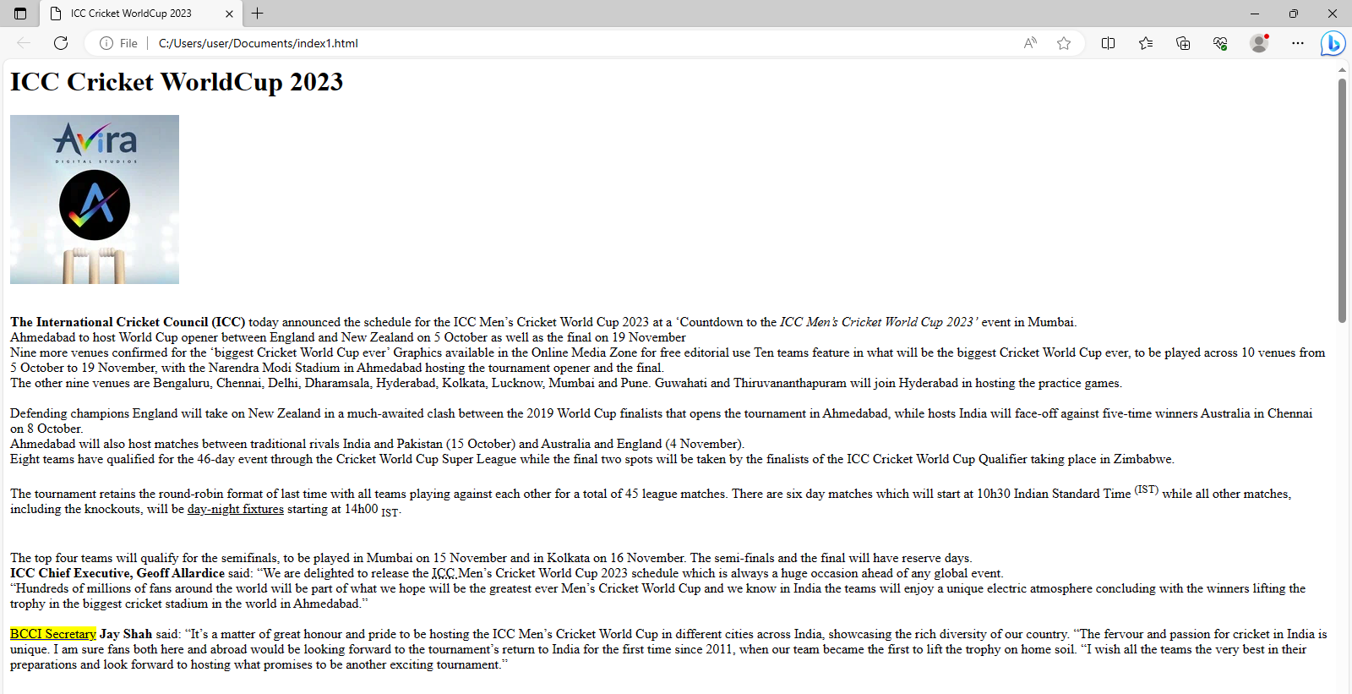

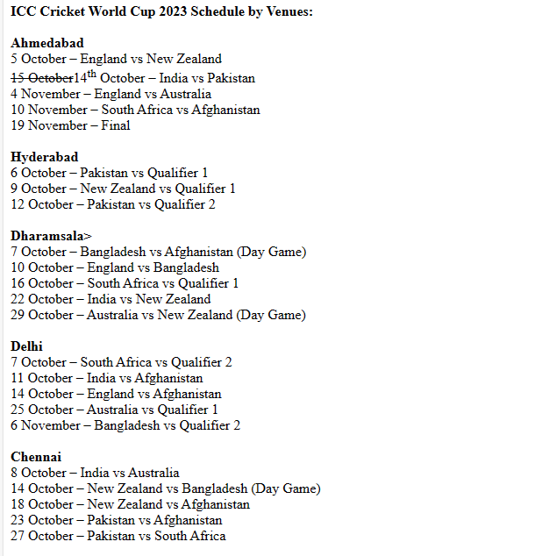

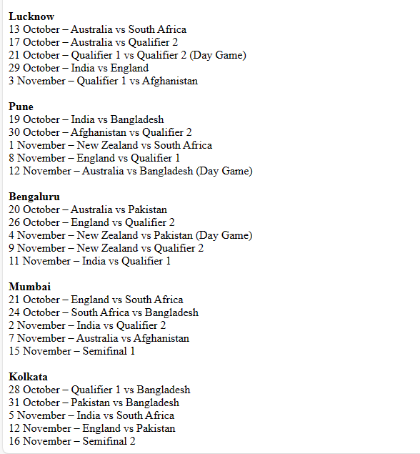

## **Task 3**

**Explore HTML Emojis from the following link:** [**https://www.w3schools.com/html/html_emojis.asp**](https://www.w3schools.com/html/html_emojis.asp)

<!DOCTYPE html>

<html>

<head>

<meta charset="UTF-8">

</head>

<body>

<h1>Sized Emojis</h1>

<p style="font-size:48px">

&#128512; &#128516; &#128525; &#128509;

</p>

</body>

</html>

